Year 12 Human Biology
Reaction Time Validation Test

Name:
Teacher:

 | Marks Received | Marks Available | Percentage
Test |  | 35
Report |  | 5
Total |  | 40

Weighting 5%

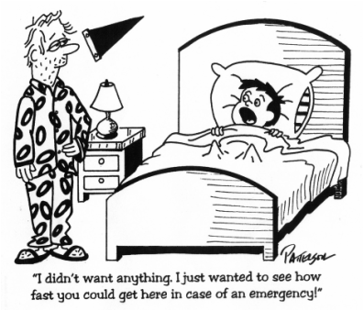

Use the report you have prepared on your investigation to answer questions 1 to 10.

1. What was your hypothesis?

(1 mark)

2. Identify the independent and dependant variables in this investigation

(2 marks)

3. What was the “Control Group” in your investigation?

(2 marks)

4. Identify three extraneous (uncontrolled) variables in either the method or equipment used in the investigation. Describe how you could control each variable.

(3 marks)
5. Do you think your hypothesis was supported:
a) by the overall data? Explain
(1 mark)
b) by all individuals within the data? Explain.

(1 mark)
6. You were asked not to practise using the “Reaction Timer” before collecting data. How could this have affected your investigation?

(2 marks)

7. To find out if your experiment was affected by the practise effect, plot your data for three
members of your group for their 5 trials for the “Before” or “Normal” situation on the grid
below (Hint. Trial number is on the horizontal axis).
(3 marks)


8. Use evidence from your graph to decide if your data has been affected by the practise effect.

(2 marks)

9. What are the overall median and range of the data from all data displayed on the graph above?
Explain how you calculated each one.

(4 marks)

10. Discuss the reliability of your results.

(3 marks)

Use the following information to answer question 11.

11. Below are the results of an investigation into braking response times under different conditions. Brown is a 22 year old, and Alterman is 37 years old. “Reading” is reading a text message on a mobile phone, “Texting” is typing the message that they had received and “Impaired” refers to a blood alcohol reading of above 0.08 percent.

Table 1: Reaction time averages at Table 2: Reaction time averages at
35 miles/hr 70 miles/hr
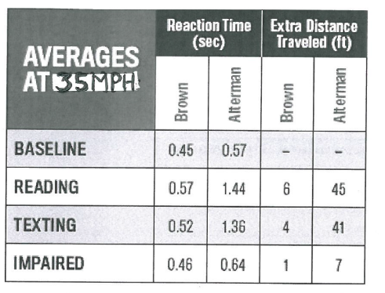
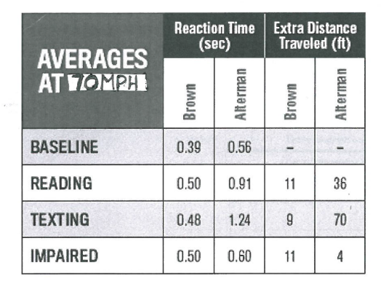

Graph 1: Worst reaction distances (feet)
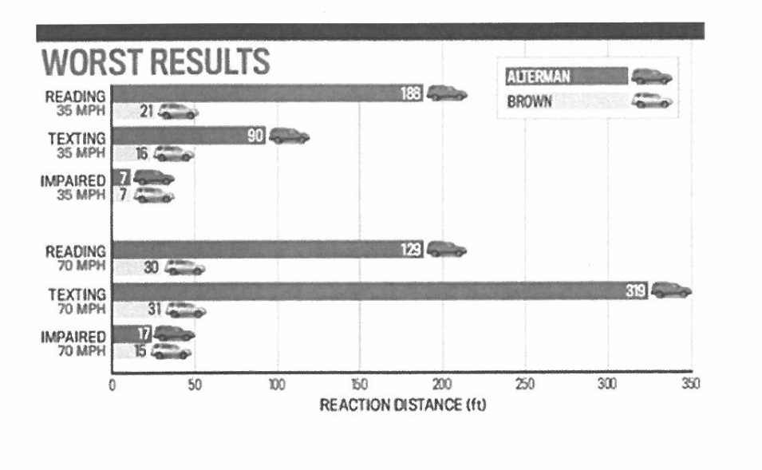

a) Give two possible hypotheses for this investigation.

Hypothesis 1: _______________________________________________________________
___________________________________________________________________________
Hypothesis 2: _______________________________________________________________
___________________________________________________________________________
(2 marks)

b) Draw a conclusion for one of your hypotheses above. (indicate which hypothesis you have chosen) Justify your conclusion using evidence from the results.

(3 marks)
c) In the results shown in Graph 1 there was an obvious outlier. Which result do you think this was? Why was this result considered to be an outlier? Make a prediction as to what this value should have been.

(4 marks)
d) A “risk assessment” is a process where the potential risks that may be involved in an investigation are evaluated and measures are taken to prevent harm to any participants.
Discuss two factors which would need to be considered in the Braking Response Time investigation and describe ways of minimising them.

(2 marks)

